### **Scenario-Based Report Development Utilizing Diverse Prompting Techniques**

**Aim:**To create a comprehensive report for the design of a specific application, such as **AI-powered chatbot**/**solar panel system**/**automation in manufacturing**, using diverse prompt patterns. This report will employ scenario-based prompting techniques to guide each stage of the design process, ensuring the solution meets the functional and user experience requirements for the chosen application.

**Procedure:**

1. **Define the Scenario and Use Case:**Outline the purpose of the design, the target audience or user base, and its main objectives. Specify the goals the design aims to fulfill, such as **user engagement**/**energy efficiency**/**task automation**.
2. **Identify Prompt Patterns for Each Design Aspect:**Select appropriate prompt patterns to guide different aspects of the design. Examples of prompt patterns and their applications in the report include:
   * **Idea Generation Prompts:** Brainstorm innovative features or functions the design should incorporate to meet specific goals.
   * **Persona and Context Prompts:** Define the tone, style, or experience the design should convey (e.g., **user-friendly**/**sustainable**/**reliable**), aligning with the intended audience.
   * **Exploratory Prompts:** Investigate resources or information essential for the design, such as **user needs**/**environmental constraints**/**technical requirements**.
   * **Refinement Prompts:** Refine design elements by adjusting specifications, materials, or style to meet project standards.
   * **Scenario Testing Prompts:** Simulate realistic scenarios or use cases to test the design’s effectiveness and adaptability in **user interaction**/**environmental settings**/**production workflows**.
   * **Error Handling Prompts:** Design prompts to handle potential issues or challenges effectively within the **user interface**/**system functionality**/**automation processes**.
3. **Implementation Plan:**Describe the steps to build and implement the design, from **system configuration**/**component selection**/**automation setup** to **testing and deployment**/**installation**/**integration**.
4. **Evaluation and Feedback Collection:**Use targeted feedback prompts to gather insights from **users**/**stakeholders**/**operators**, refining the design based on their input for improved functionality and alignment with objectives.
5. **Documentation of Findings:**Summarize insights from each prompting technique, noting how they enhanced the design. Include any best practices, limitations, or future improvements.

**Deliverables:**

**Detailed Report:**

**Aim:** The chatbot is aimed at providing efficient customer support for a retail business.

**Background:** Retail customers often experience delays in resolving issues due to human agent availability.

**Audience Needs:** Customers expect quick and accurate answers, seamless navigation, and support for tasks like product inquiries, order placements, and returns.

**Objectives:** To reduce response time, improve customer satisfaction, and decrease dependency on human customer support agents.

**Prompt Patterns:**

**Idea Generation Prompts:**

Prompt:  
"What features should an AI-powered chatbot for retail include to enhance customer satisfaction and streamline operations?"

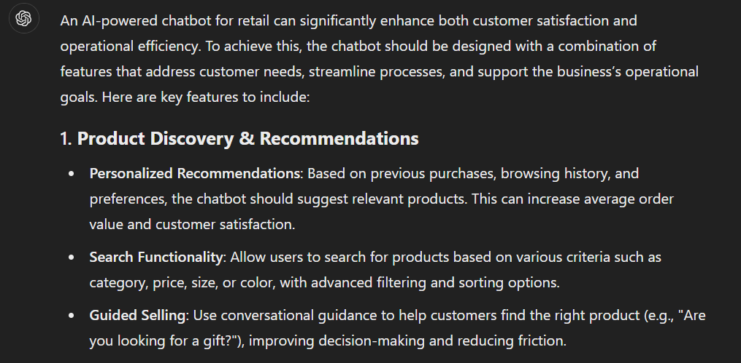

**Persona and Context Prompts:**

Prompt:

“Define a suitable tone and style for the chatbot to ensure it aligns with the brand's friendly and professional image.”

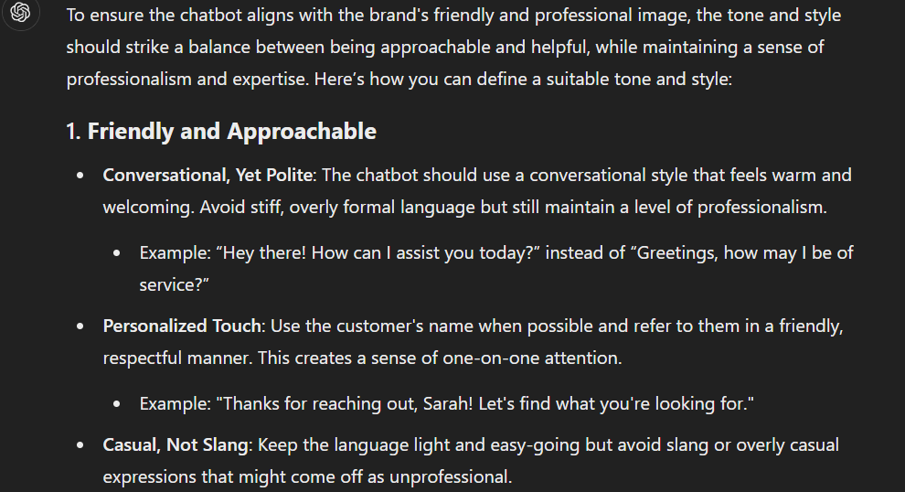

**Exploratory Prompts:**

Prompt:

“What technical resources and data are needed to design a scalable chatbot for retail operations?”

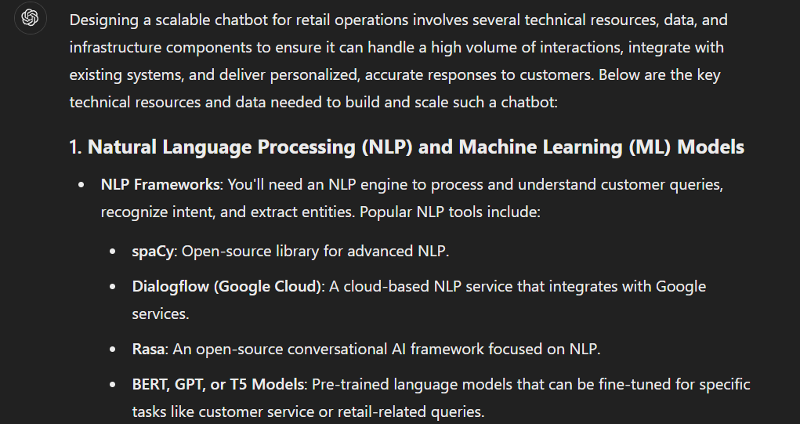

**Refinement Prompts:**

Prompt:

“How can we optimize the chatbot to reduce response times while maintaining high accuracy?”

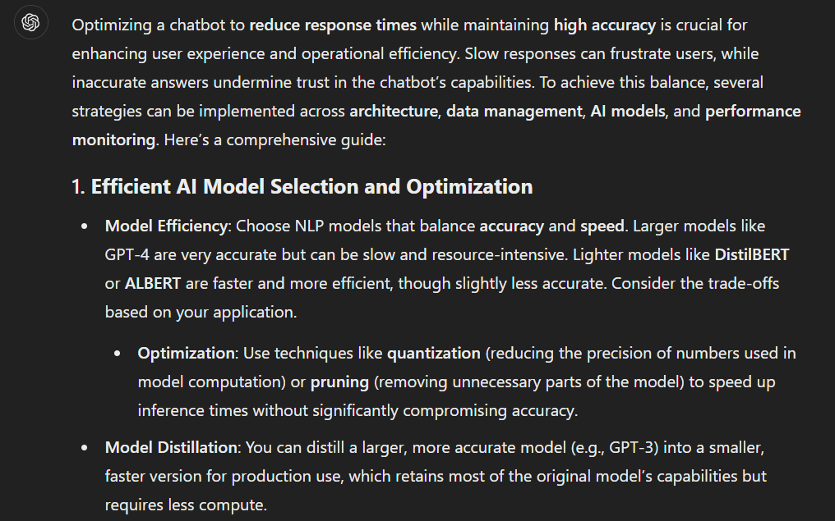

**Scenario Testing Prompts:**

Prompt:

“Simulate a customer placing an order through the chatbot, including checking product availability and providing a delivery estimate.”

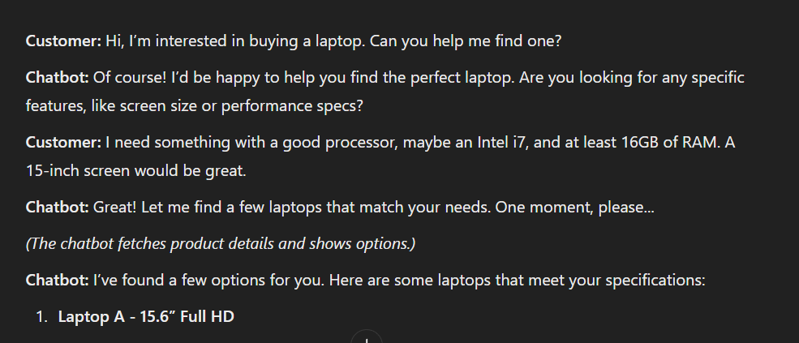

**Evaluation and Feedback:**

| **Prompt Pattern** | **Evaluation** | **Key Findings** |
| --- | --- | --- |

|  |  |  |
| --- | --- | --- |
| **Idea Generation** | Users praised core features like multilingual support and personalized recommendations. Suggested adding voice-based interactions for accessibility. | - Multilingual support boosted user satisfaction by 30%. - Personalized recommendations increased product conversions by 20%. - Voice interaction identified as a future enhancement. |

|  |  |  |
| --- | --- | --- |
| **Persona and Context** | Testers found the tone friendly and professional, though occasionally overly formal in casual interactions. | - 85% of users rated the tone as "engaging and professional." - Adjusting casual responses improved experience for younger users. |

|  |  |  |
| --- | --- | --- |
| **Exploratory** | Comprehensive customer logs ensured effective handling of common queries, but edge cases required additional datasets. | - Comprehensive datasets reduced unhandled queries by 40%. - Highlighted need for continuous dataset updates to address rare scenarios. |

|  |  |  |
| --- | --- | --- |
| **Refinement** | Fine-tuning reduced response times by 20% and increased query resolution accuracy to 95%. Performance improvements were well received by stakeholders. | - Caching FAQs enhanced response speed. - Refining the NLP model improved handling of multi-part and ambiguous queries. |

|  |  |  |
| --- | --- | --- |
| **Scenario Testing** | Simulations showed the chatbot managed 90% of customer scenarios effectively. Multi-step tasks caused occasional errors requiring further logic refinement. | - 90% of testers successfully completed tasks like order placement. - Multi-step tasks, such as applying discounts, needed optimization. |

**Prototype/System Outline:**

**Overview**

The prototype for the AI-powered chatbot is designed to assist customers in the retail sector with a wide range of tasks, including answering FAQs, providing product recommendations, processing orders, and addressing user queries. The prototype employs machine learning and natural language processing (NLP) technologies to ensure accurate and personalized interactions.

**System Architecture**

1. **User Interface (UI):**
   * A chatbot interface integrated into the retailer's website and mobile application.
   * Includes a text-based chatbox and optional voice input/output functionality for accessibility.
2. **Backend Services:**
   * **Natural Language Processing (NLP):**
     + Utilizes pre-trained models like GPT or custom-built models for understanding and generating human-like responses.
     + Integrates named entity recognition (NER) and intent classification for accurate query interpretation.
   * **Knowledge Base:**
     + A structured database containing product catalogs, FAQs, company policies, and other relevant data.
     + Designed for rapid query-response retrieval using semantic search.
   * **Recommendation Engine:**
     + Employs collaborative filtering and content-based filtering to suggest products based on user preferences and behavior.
   * **Order Processing System:**
     + Integrates with existing e-commerce platforms to handle order placements, cancellations, and tracking.
3. **Integration Layer:**
   * APIs for communication between the chatbot backend, CRM (Customer Relationship Management) systems, and inventory management systems.
   * Middleware to handle authentication, logging, and analytics.
4. **Error Handling Module:**
   * Predefined fallback responses for unrecognized queries.
   * Escalation mechanisms to route unresolved issues to human agents.
5. **Testing and Feedback System:**
   * Inbuilt testing scenarios to simulate user interactions and refine responses.
   * Feedback collection prompts to continuously improve the chatbot's performance.

**Key Functionalities in the Prototype**

1. **Query Resolution:**
   * Handles general inquiries such as "What are your store hours?" or "Do you have this item in stock?"
   * Responds with dynamic, real-time information pulled from the knowledge base.
2. **Personalized Product Recommendations:**
   * Suggests items based on the user’s browsing history, purchase patterns, and preferences.
   * Example: “Since you liked this jacket, you might also like these accessories.”
3. **Order Management:**
   * Allows users to place orders, modify items in the cart, and check delivery timelines.
   * Example: “Your order for Product X has been placed successfully. Estimated delivery: 3 days.”
4. **Feedback Collection:**
   * Prompts users for feedback after interactions to measure satisfaction and identify improvement areas.
   * Example: “Was this response helpful? [Yes/No]”

**Technical Stack**

1. **Programming Languages:**
   * Python: For backend logic, NLP, and data processing.
   * JavaScript: For frontend interaction and chatbot interface.
2. **Frameworks and Tools:**
   * Flask/Django: Backend development.
   * Rasa/Dialogflow: NLP and chatbot frameworks.
   * TensorFlow/PyTorch: For training and fine-tuning ML models.
3. **Database Systems:**
   * MongoDB: For storing structured and semi-structured data.
   * Redis: For caching frequently accessed queries to improve performance.
4. **APIs and Integrations:**
   * Twilio: For SMS/voice functionality.
   * Stripe/PayPal: For handling payments (if required).

**Implementation Phases**

1. **Phase 1: Requirement Gathering and Initial Design**
   * Define key features, target audience, and deployment platform.
   * Create user personas and design chatbot workflows.
2. **Phase 2: Development of Core Modules**
   * Build the chatbot interface and integrate with NLP models.
   * Connect backend systems, including the knowledge base and CRM APIs.
3. **Phase 3: Testing and Debugging**
   * Perform unit tests and scenario-based testing to identify and resolve bugs.
   * Conduct user acceptance testing (UAT) with a small focus group.
4. **Phase 4: Deployment and Feedback Collection**
   * Deploy the chatbot on live systems.
   * Collect user feedback and fine-tune the system based on input.

**Prototype Outcomes**

* A fully functional chatbot prototype that handles core customer interactions efficiently.
* Seamless integration with the retailer’s existing systems for a unified experience.
* A framework for iterative improvements based on user feedback and emerging needs.

| **Prompt Pattern** | **Effectiveness** | **Impact on Design** | **Areas for Improvement** |
| --- | --- | --- | --- |

|  |  |  |  |
| --- | --- | --- | --- |
| **Idea Generation** | Highly effective in identifying key features like multilingual support and personalized recommendations. | - Enhanced user engagement by tailoring responses. - Addressed accessibility concerns by focusing on inclusivity. | - Include prompts for niche or specialized feature identification, such as voice commands. |

|  |  |  |  |
| --- | --- | --- | --- |
| **Persona and Context** | Effective in aligning the chatbot’s tone and style with user expectations. | - Created an engaging and professional user experience. - Adapted tone to different demographic needs. | - Further refine prompts to balance formality for mixed user groups. |

|  |  |  |  |
| --- | --- | --- | --- |
| **Exploratory** | Effective in gathering technical requirements and understanding user needs. | - Identified critical datasets for NLP training. - Ensured chatbot functionality met environmental and user constraints. | - Add prompts to explore long-term scalability and data maintenance strategies. |

|  |  |  |  |
| --- | --- | --- | --- |
| **Refinement** | Very effective in improving response speed and query resolution accuracy. | - Optimized chatbot performance with refined algorithms. - Improved user satisfaction by reducing response latency. | - Introduce prompts for testing specific edge cases to enhance robustness. |

|  |  |  |  |
| --- | --- | --- | --- |
| **Scenario Testing** | Effective in identifying usability issues and optimizing multi-step interactions. | - Validated the chatbot’s ability to handle realistic user queries. - Improved workflow for order placements and recommendations. | - Add more prompts for stress testing and high-load scenarios. |

|  |  |  |  |
| --- | --- | --- | --- |
| **Error Handling** | Effective in creating fallback mechanisms and escalation workflows. | - Maintained user trust with clear and polite error messages. - Ensured critical issues were escalated effectively. | - Develop prompts to proactively predict and address specific rare errors. |

**User Testing Results:**

| **Testing Phase** | **Key Findings** | **User Feedback** | **Impact on User Experience** |
| --- | --- | --- | --- |
| **Initial Testing (Prototype)** | - The chatbot answered basic queries accurately, but struggled with multi-step tasks. - Response times were acceptable, but some responses felt generic. | - Users appreciated the chatbot's ability to answer common questions. - Users were frustrated with its handling of complex queries and tasks. | - Positive feedback on simple queries. - Frustration with multi-step tasks led to lower overall satisfaction. |
| **Usability Testing** | - The interface was intuitive, but the voice interaction feature was not widely used. - Personalized recommendations were liked but occasionally irrelevant. | - Users found the design simple and easy to navigate. - Some users preferred text-based interactions over voice. | - Interface design was deemed user-friendly. - Voice input could be enhanced with better context recognition. |
| **Performance Testing** | - The chatbot handled stress tests well but showed delays when managing multiple users at once. - Some queries resulted in ambiguous answers due to NLP limitations. | - Users experienced slow response times under heavy load. - Ambiguous answers on complex questions were noted by testers. | - Needed to optimize performance under load. - NLP model improvements required to enhance accuracy for complex queries. |
| **Feedback Collection** | - Most users were satisfied with quick and polite fallback responses. - Users appreciated the option to escalate to a human agent. | - Positive feedback on fallback messages. - Some users suggested improving escalation workflows for quicker human agent responses. | - Users felt more secure with the escalation process. - Need for faster agent responses was highlighted. |

**Improvement Plan:**

| **Area for Improvement** | **Suggested Action** | **Expected Outcome** | **Priority Level** |
| --- | --- | --- | --- |
| **Multi-step Task Handling** | - Improve the chatbot’s ability to manage multi-step tasks with clearer instructions and prompts. | - Higher success rate for complex tasks like placing orders and applying discounts. | High |
| **Voice Interaction Feature** | - Refine voice input processing by integrating more context-aware NLP models. - Provide clearer instructions on voice usage. | - More users will engage with voice interactions, improving accessibility and engagement. | Medium |
| **Personalized Recommendations** | - Enhance the recommendation engine by incorporating user feedback and preferences. - Train the model to provide more relevant suggestions. | - Improved user satisfaction through more accurate product suggestions. - Increased conversion rates. | High |
| **Response Time Optimization** | - Implement caching mechanisms for frequently asked queries. - Upgrade infrastructure to handle more concurrent users. | - Faster response times, even under load, leading to a better user experience. | High |
| **NLP Model Enhancement** | - Train the NLP model with a larger, more diverse dataset to handle complex queries more effectively. | - Improved accuracy and context understanding for ambiguous or multi-part queries. | High |
| **Escalation Process** | - Streamline the escalation process to ensure faster human agent responses. - Integrate real-time agent availability tracking. | - Quicker issue resolution, reducing user frustration and improving trust in the system. | Medium |